# Build a CRUD API with Lambda and DynamoDB

Steps:

1. Create DynamoDB and enter Partition key as ID

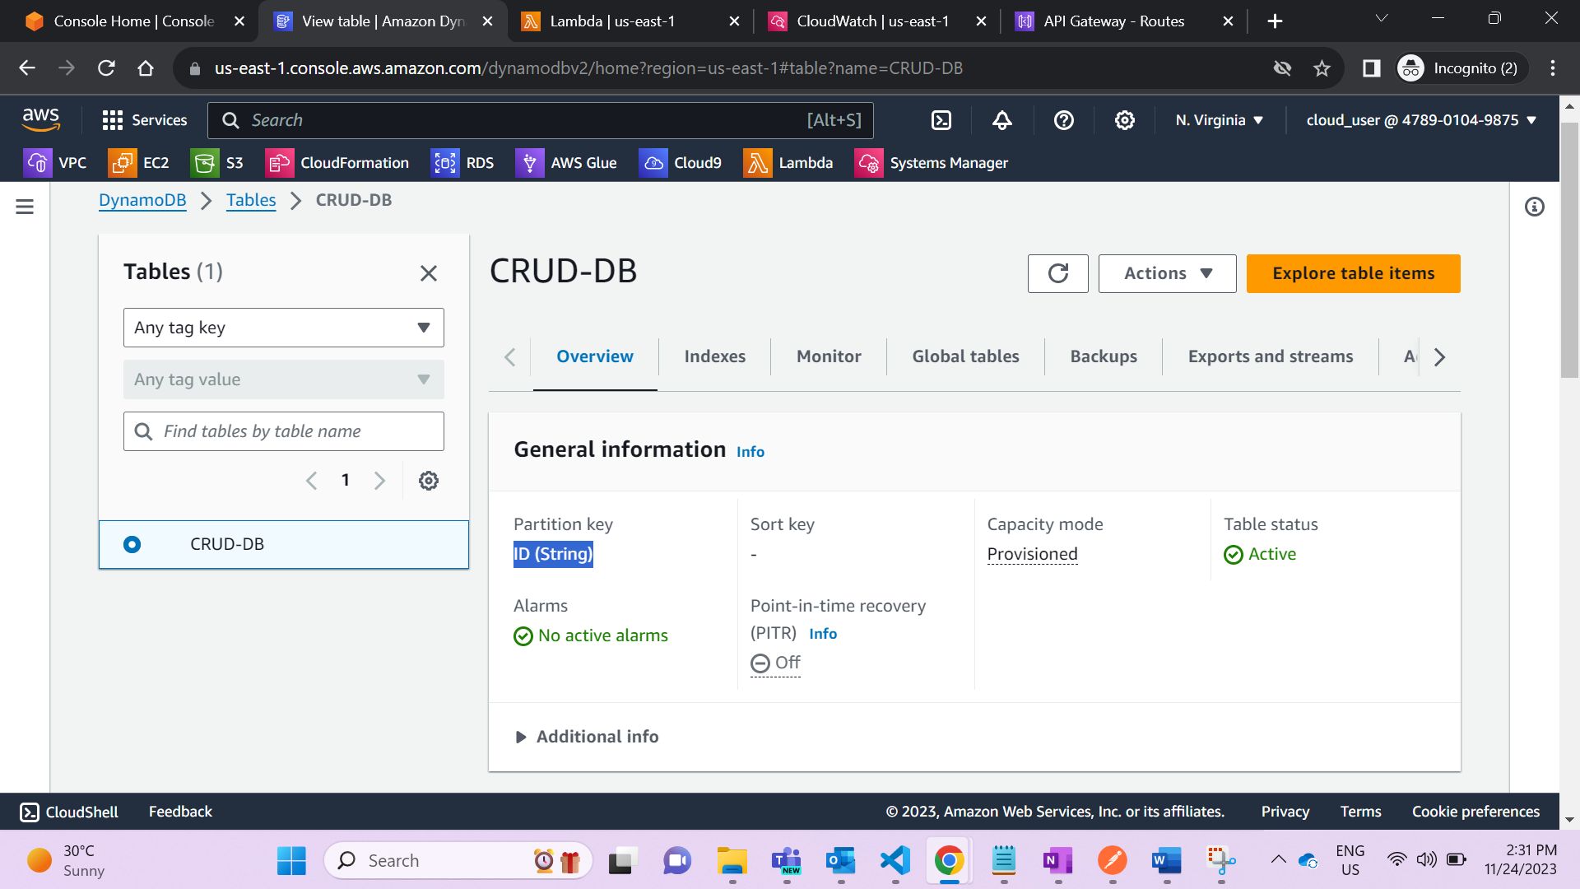

1. Create a Lambda function and attach a role to it

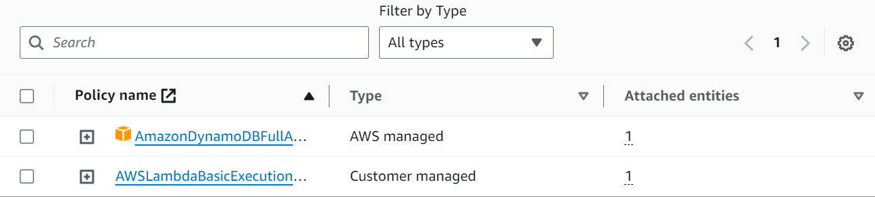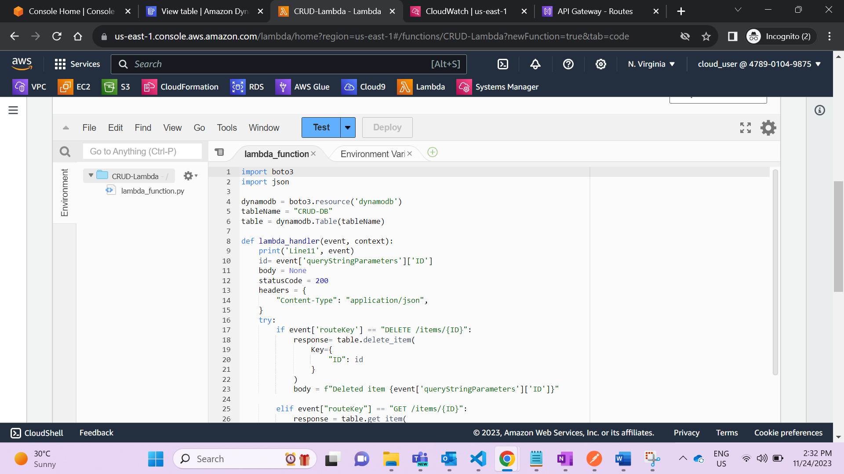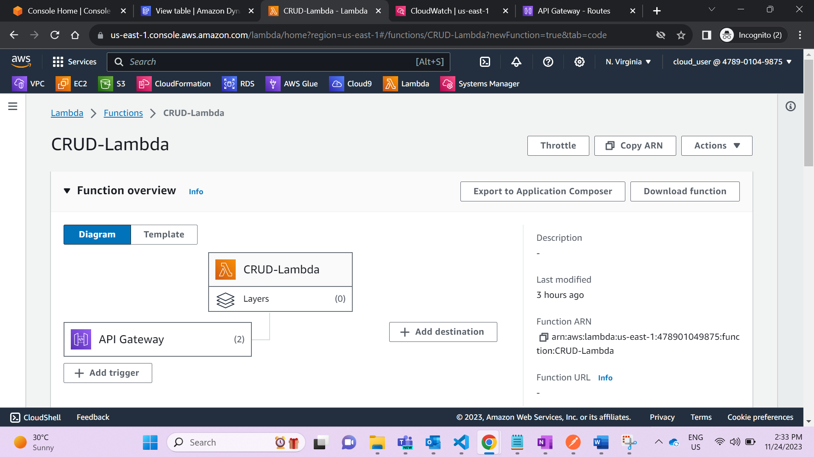

1. Create an HTTP API
2. Create routes
   1. GET /items/{id}
   2. GET /items
   3. PUT /items
   4. DELETE /items/{id}

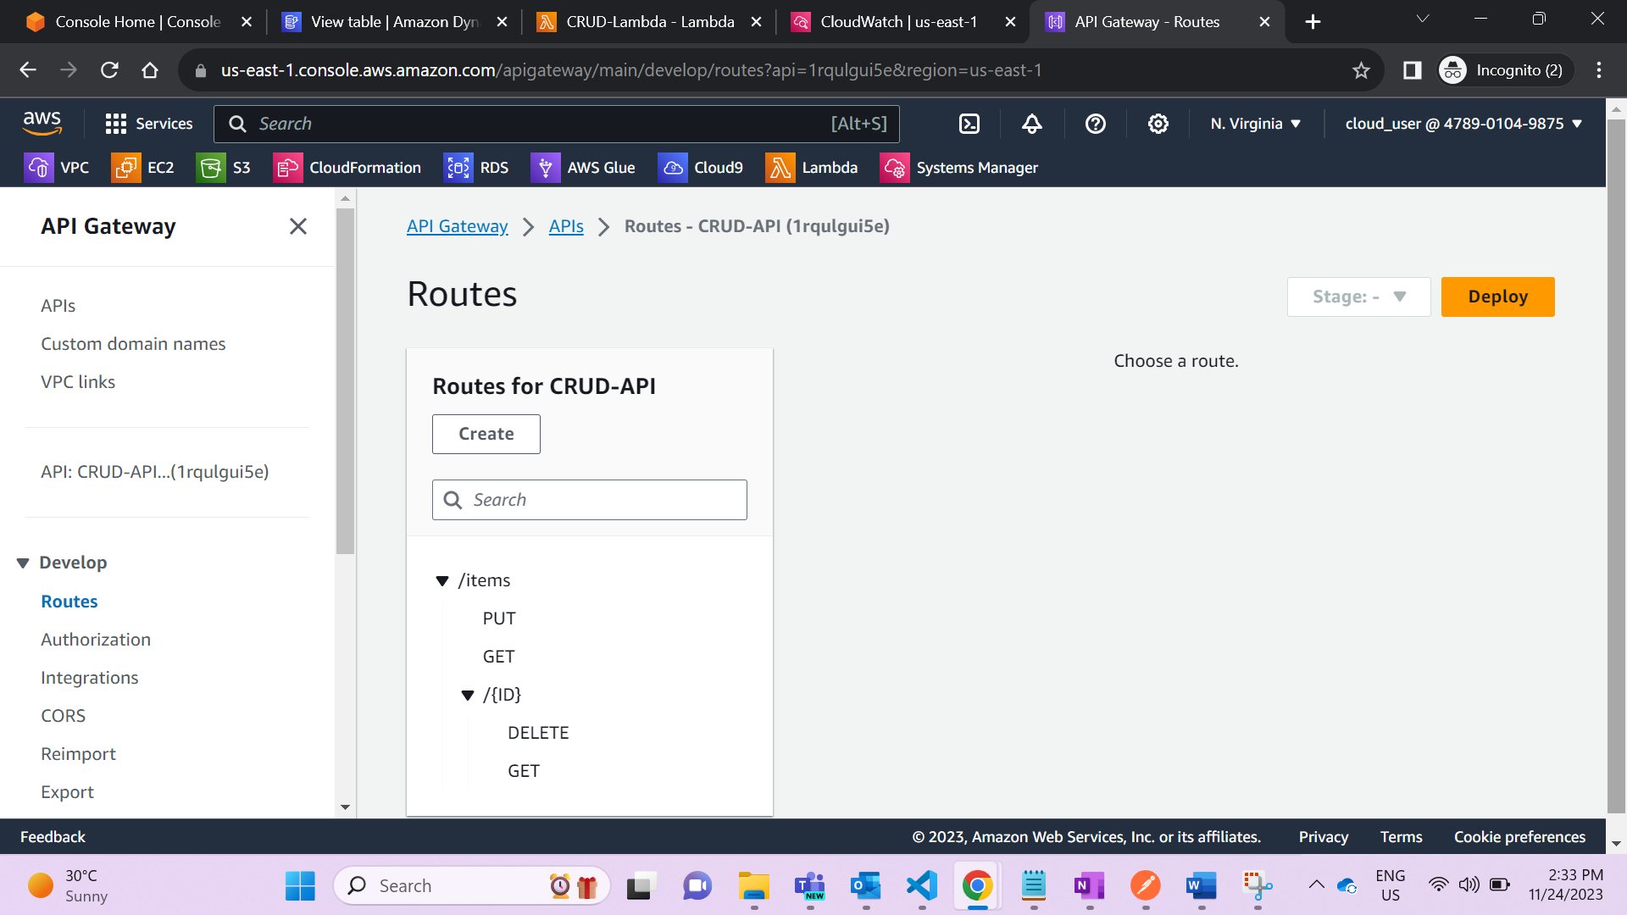

1. Create an integration

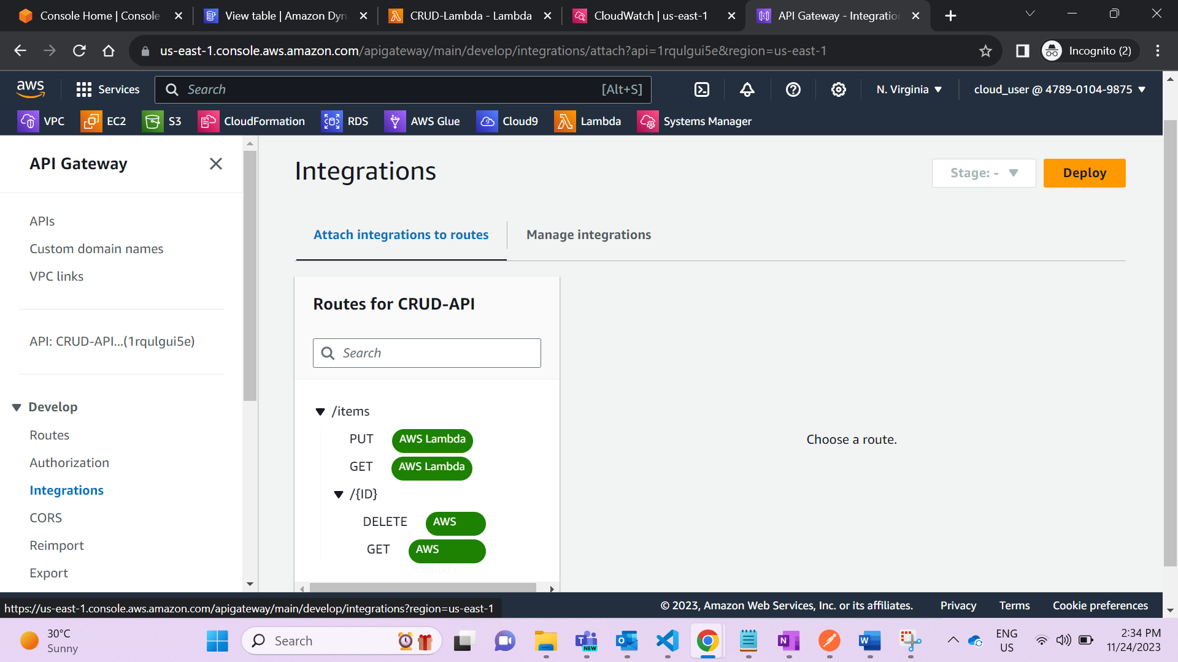

1. Attach your integration to routes



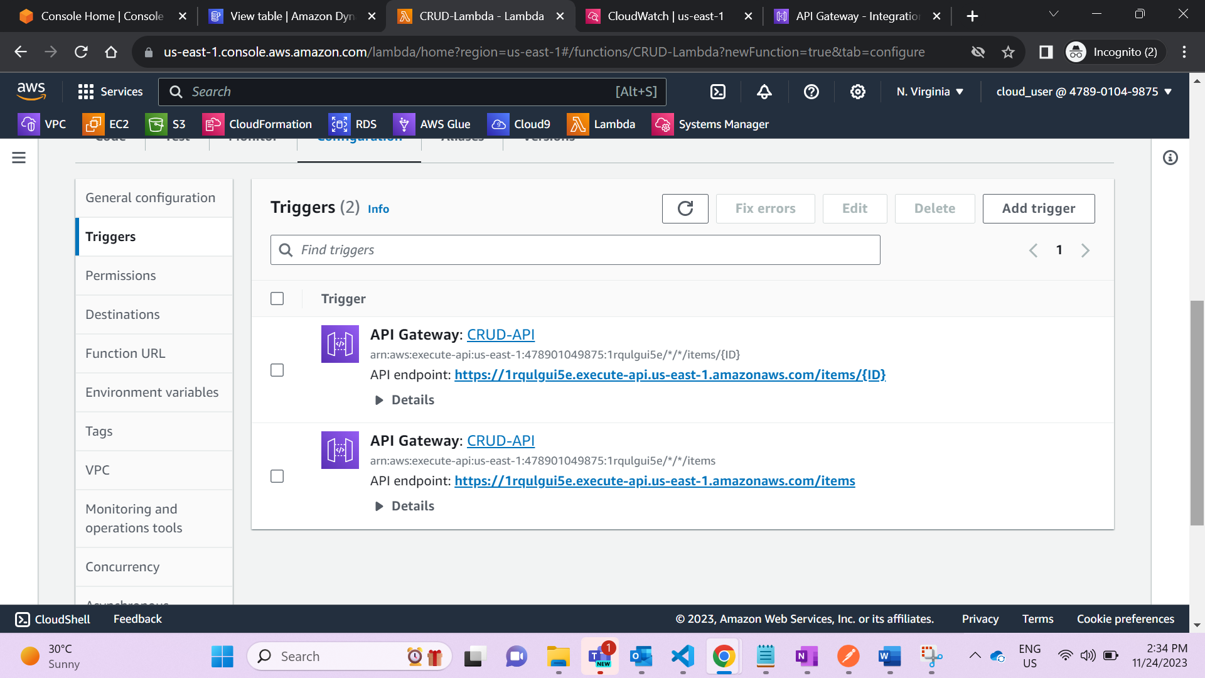

1. Test your API using Postman
2. For PUT/Item

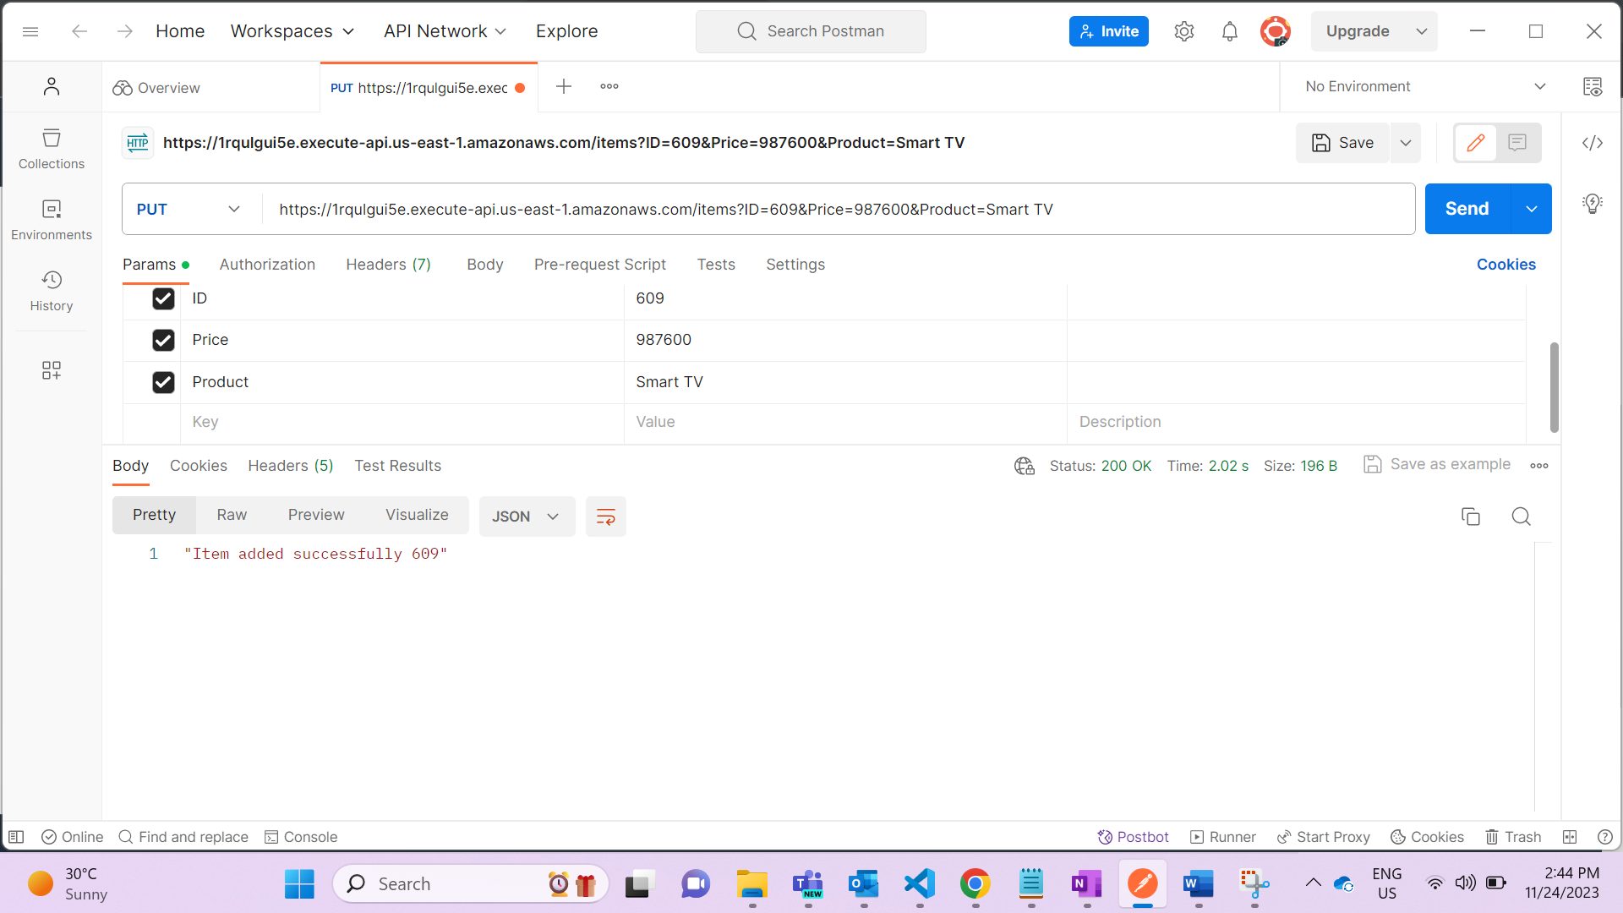

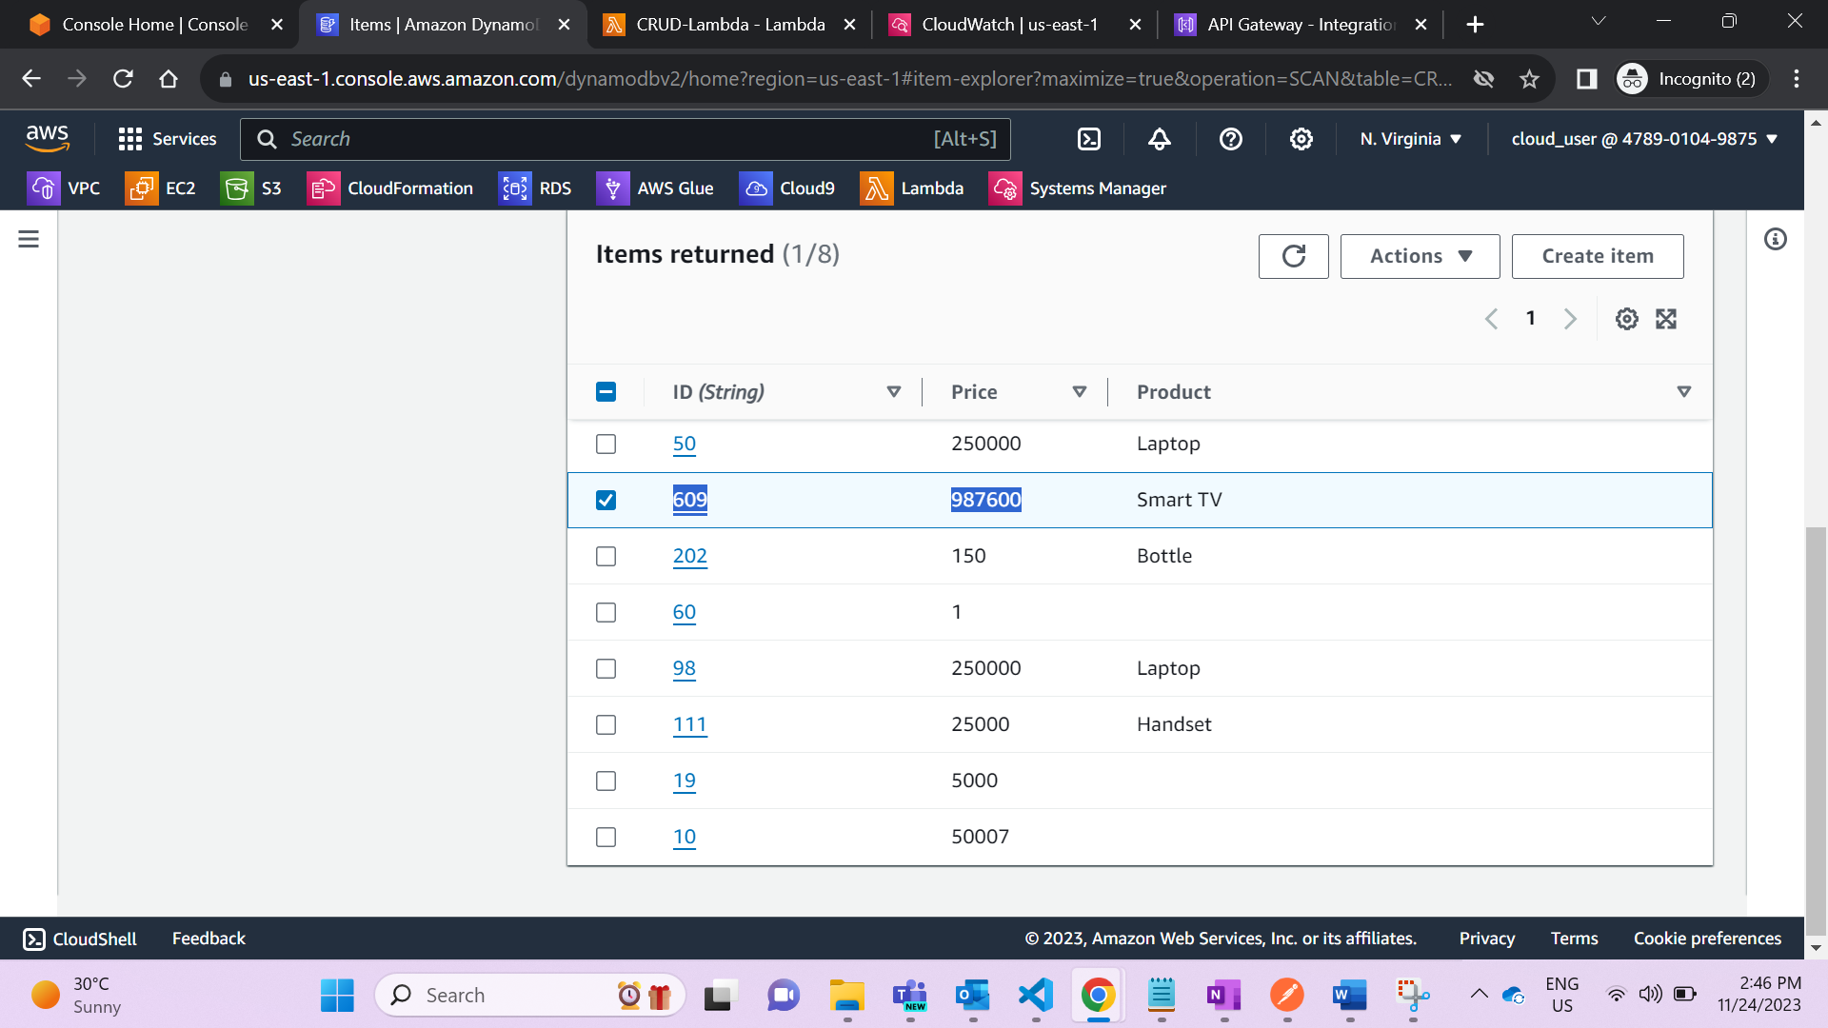

1. Get/ Item

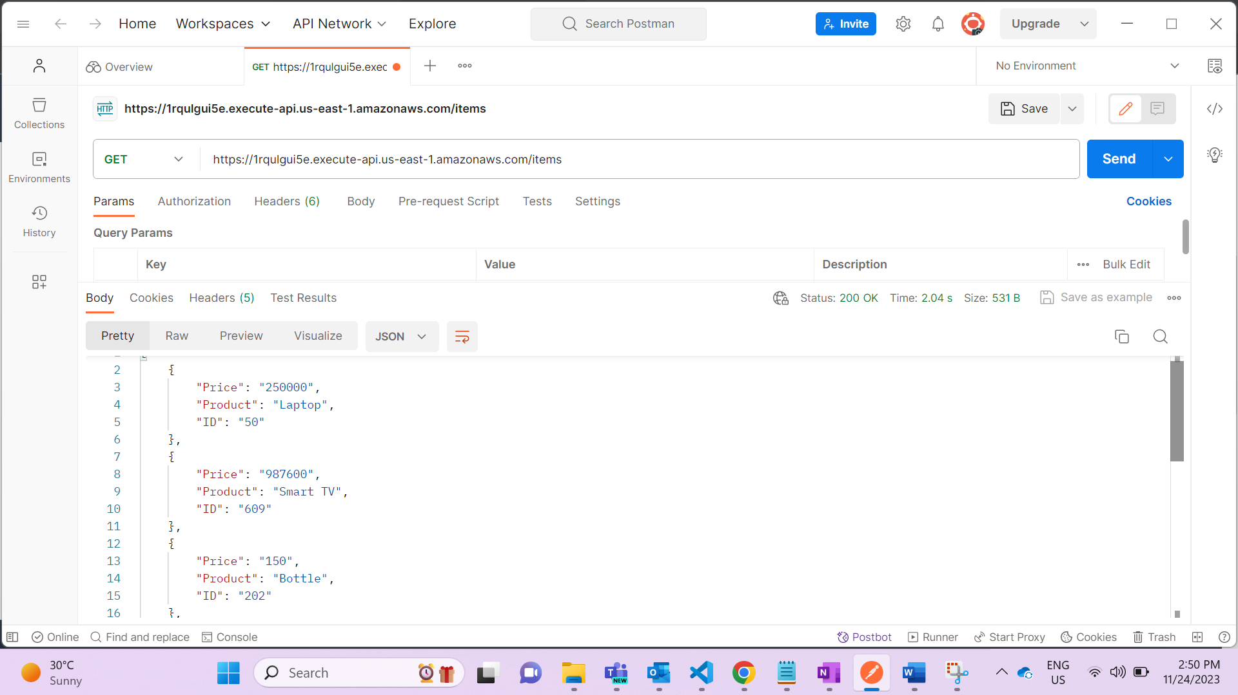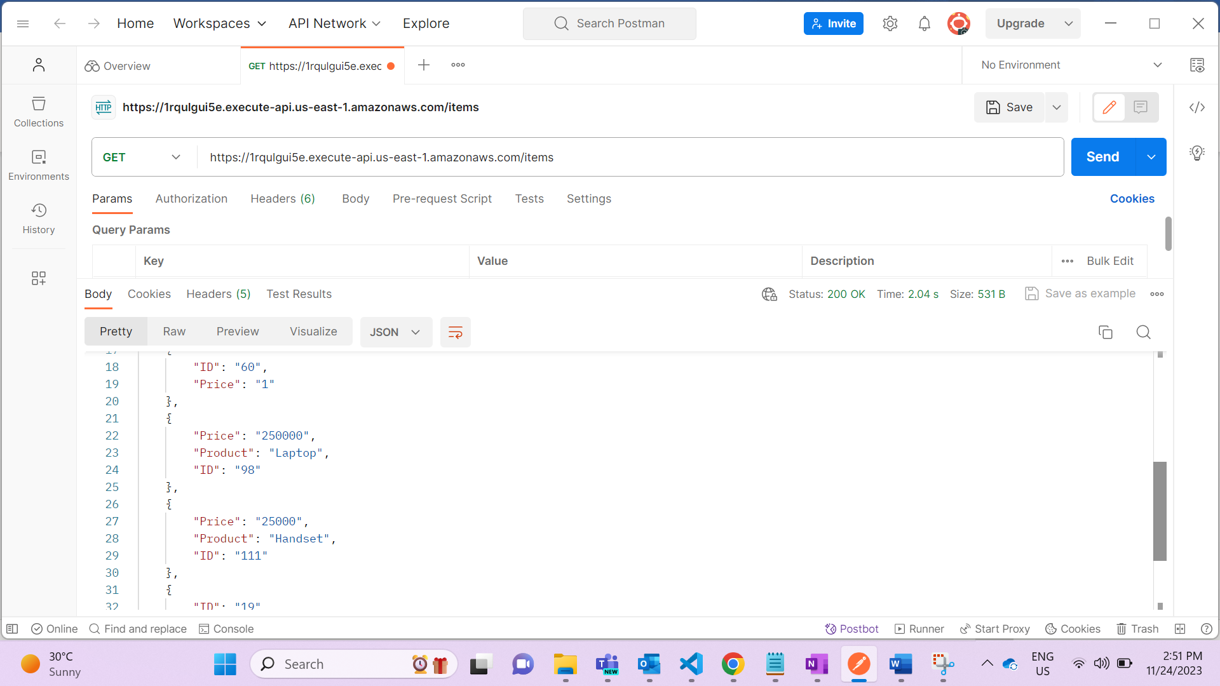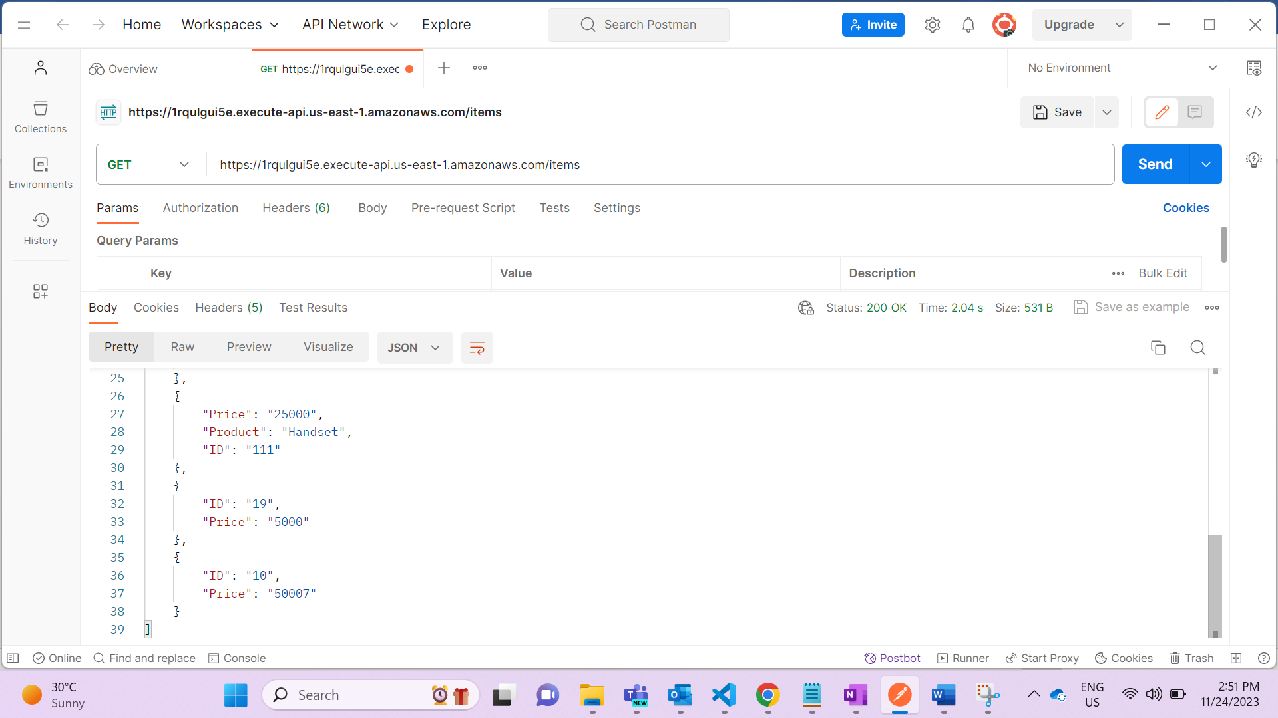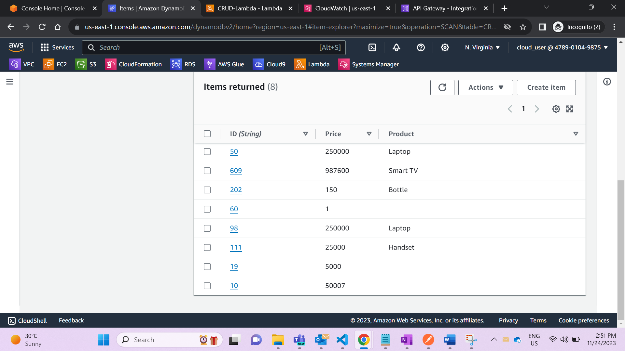

1. Get/ Items/{ID}

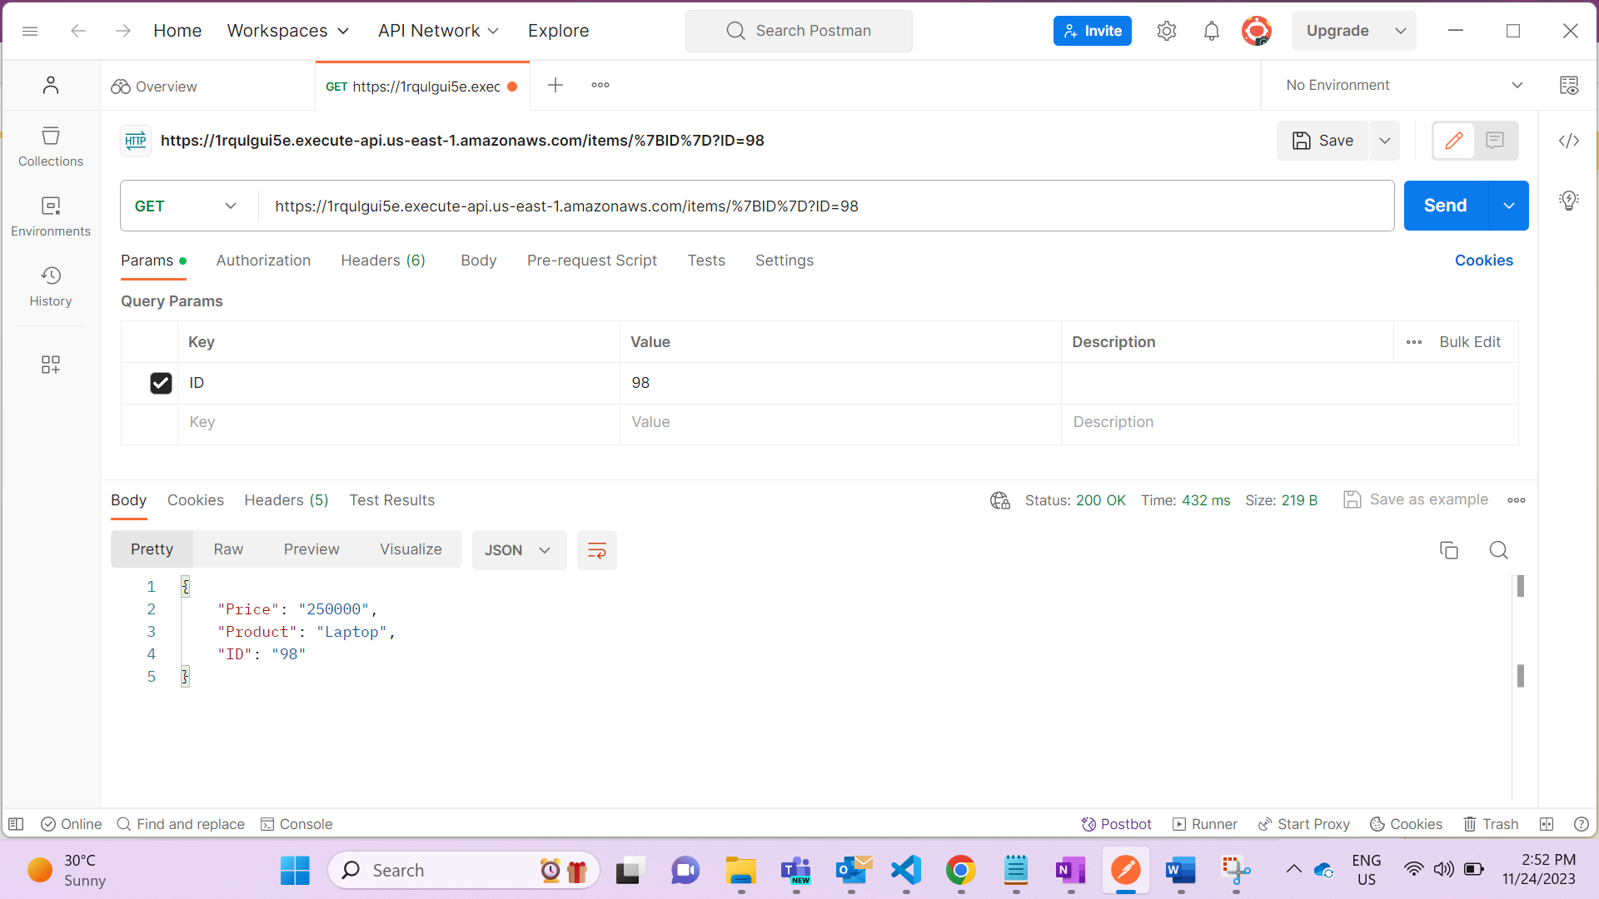

1. Delete/ Items/{ID}

